**Python Elasticsearch REST API Solution**

# Installed elasicsearch using ECK and started the service

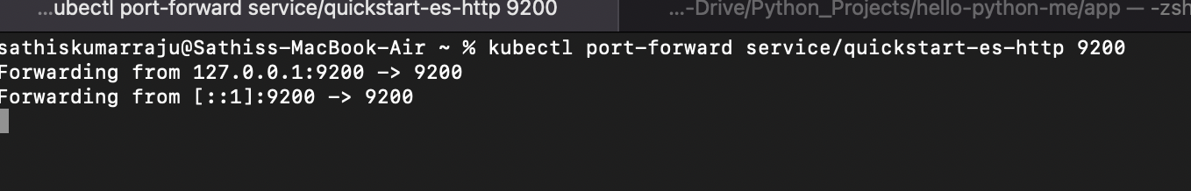

# In another terminal, check the status of the cluster

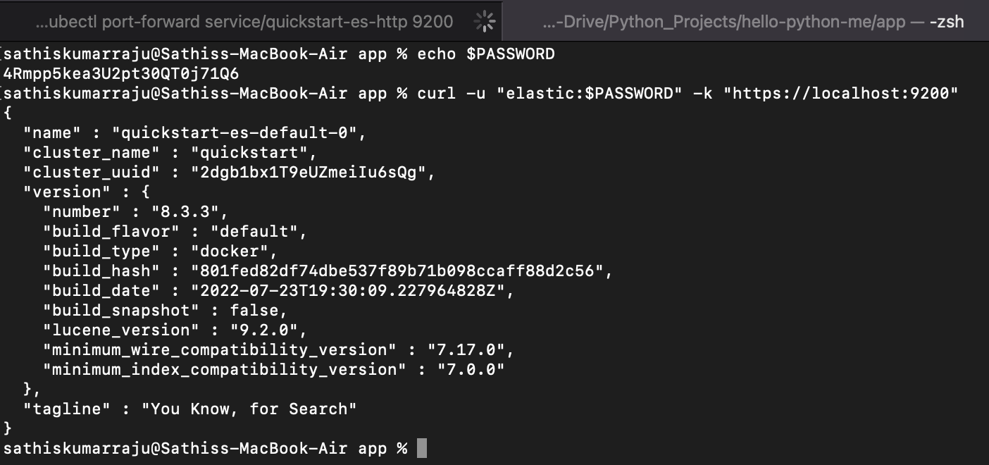

# Load data

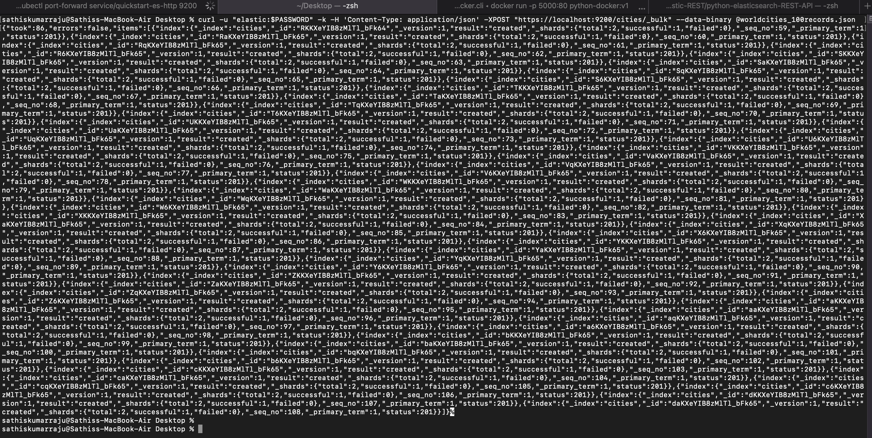

# Run Python Flask program to interact with elasticsearch API

## Install requirements.txt to install the required modules

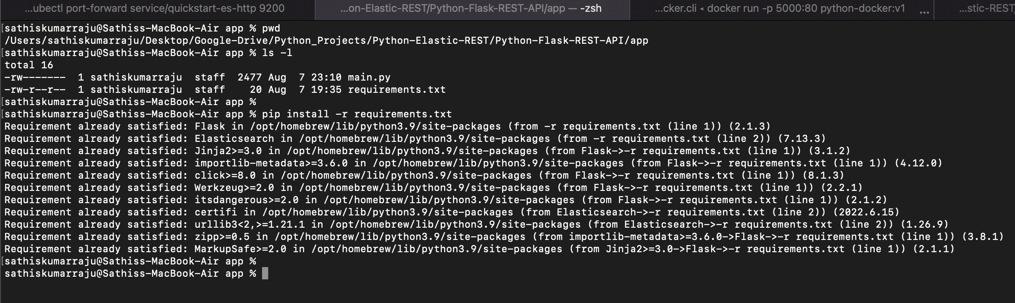

## Starting Python Web Application

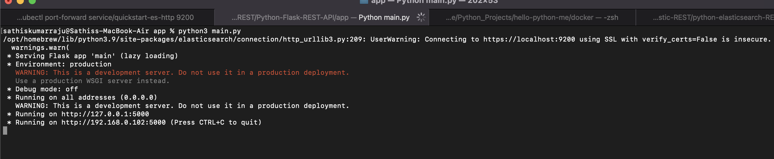

1. Both ElasticSearch & Python Web Application are currently running

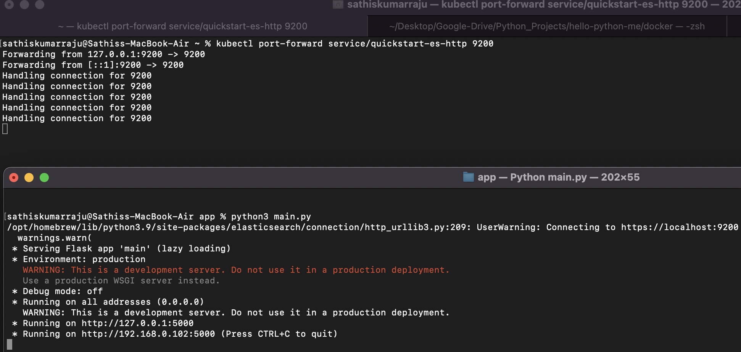

# Validation (Health Check, GET, PUT & POST)

## Health Check - GET

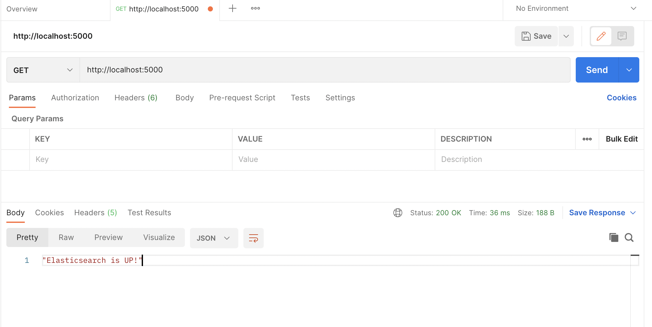

## Search an existing City – GET

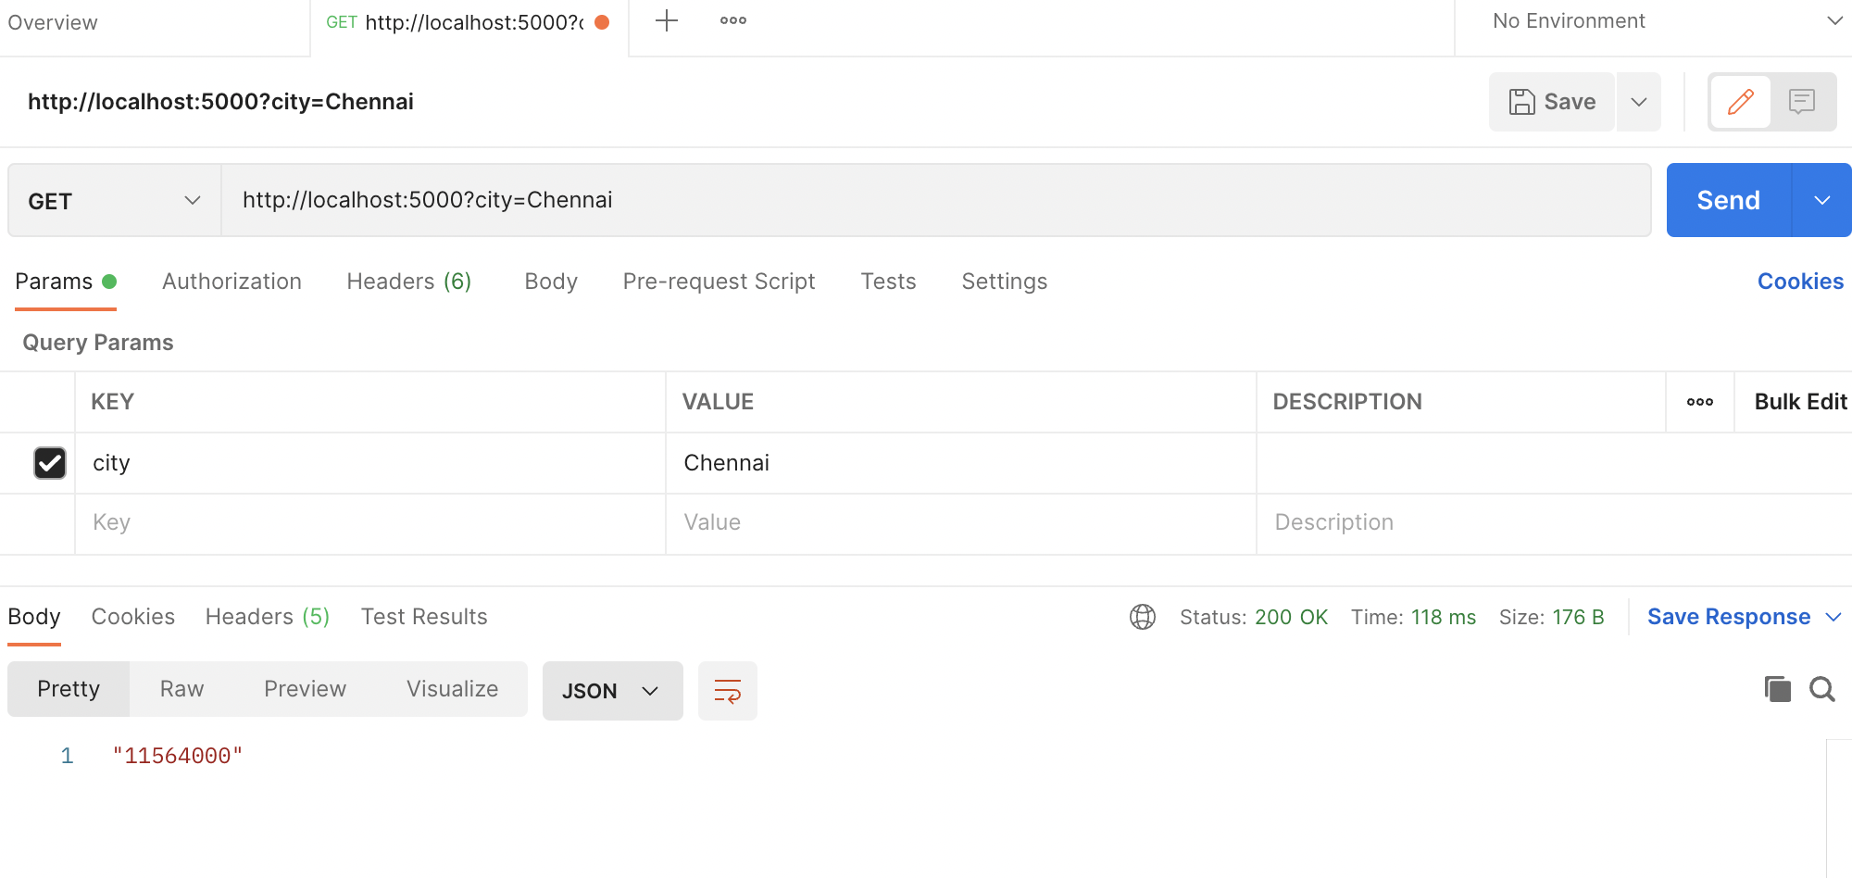

## Insert a new City – POST & then search that - GET

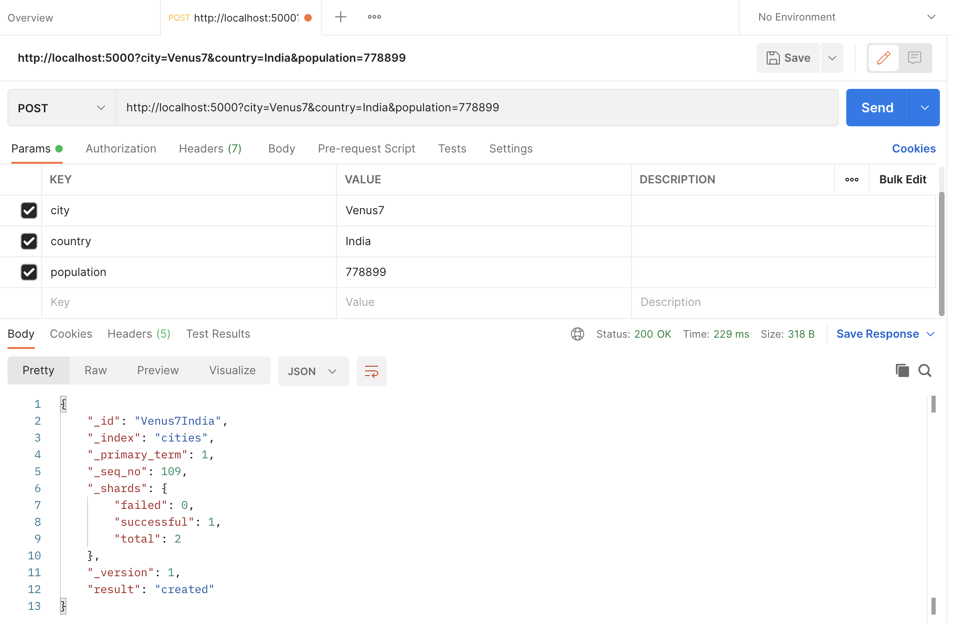

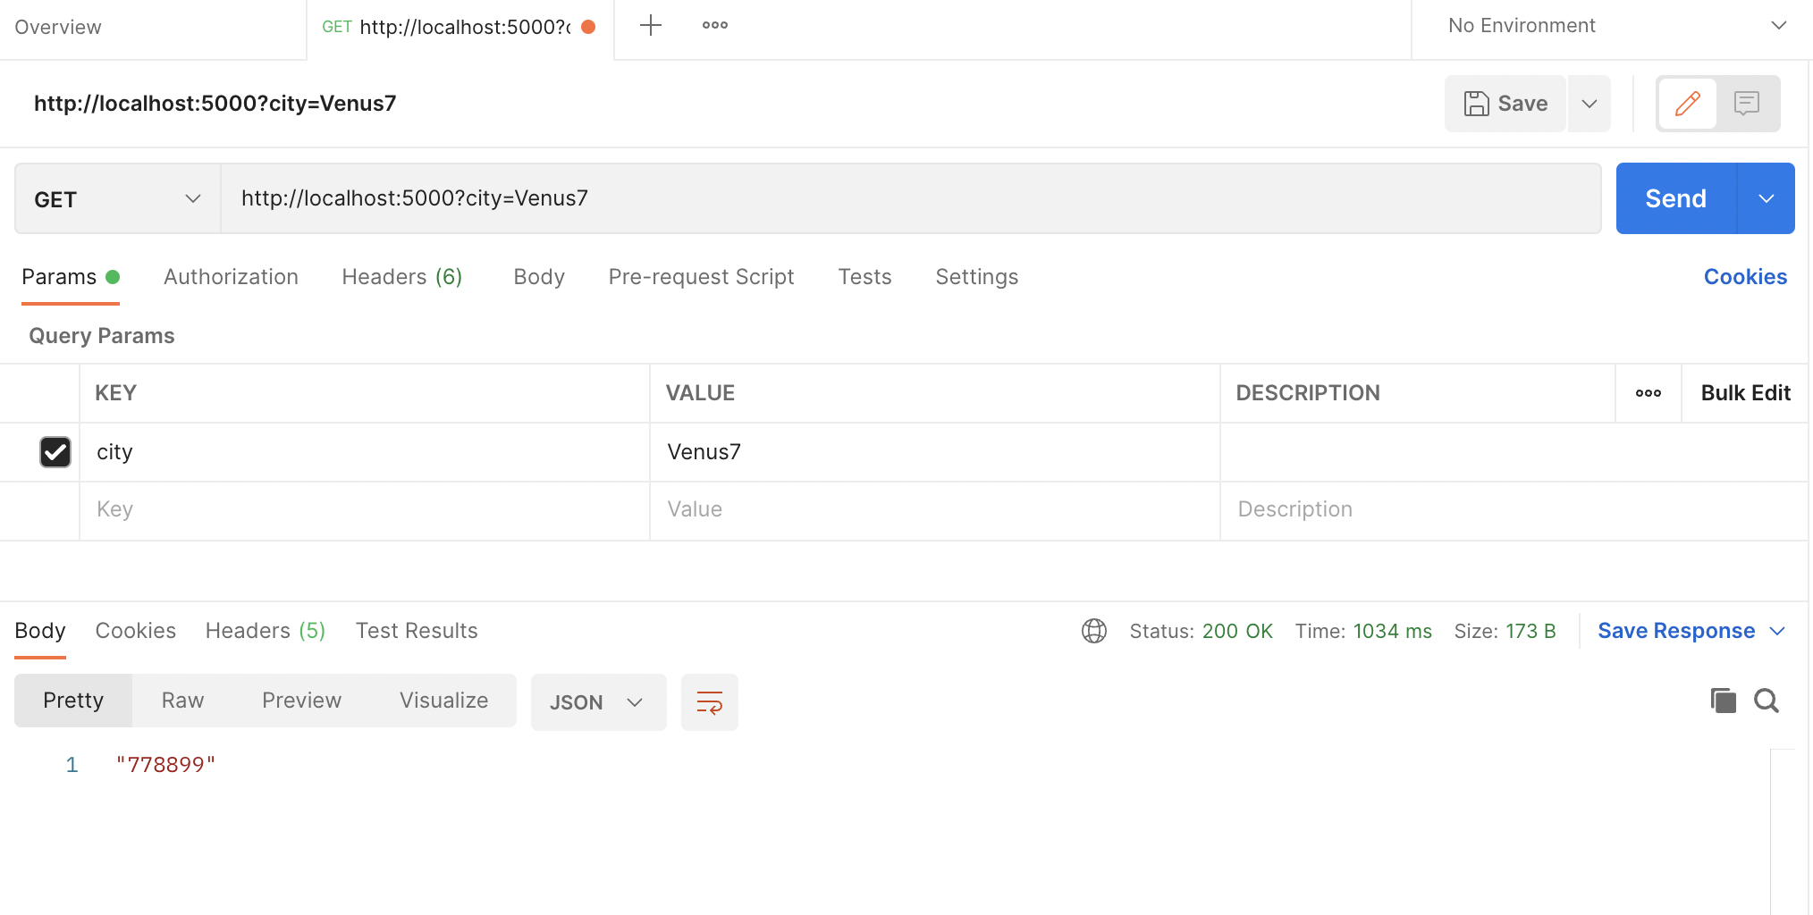

## update the existing City – PUT & then search that – GET

